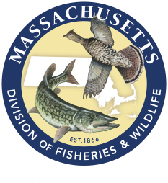

**Professional Development Workshop**

***Growing Up WILD: Exploring Nature with Young Children*** is an early childhood education activity guide that builds on children’s sense of wonder about nature and invites them to explore wildlife and the world around them. Through a wide range of activities and experiences, it provides a foundation for developing positive impressions about nature while also building lifelong social and cognitive skills. Workshop participants will receive a copy of the guide and certificate of completion.

***Growing Up WILD’s* activity guide:**

GUW-flower Is written for early childhood educators of children ages 3-7.

GUW-flower Features 27 field-tested, hands-on, nature-based activities in a full-color 11”x 17’’ activity guide.  
GUW-flower Includes crafts, art projects, music, conservation activities, reading and math connections and much   
 more.

GUW-flower Involves social, emotional, physical, language, and cognitive domains to help foster learning and   
 development in all areas.

GUW-flower Supports developmentally appropriate practice allowing children to learn at levels that are   
 individually, socially, and culturally appropriate.

GUW-flower Is correlated to the National Association for the Education of Young Children (NAEYC) Standards and   
 the Head Start Domains.

**Get *Growing Up WILD*:**

**Date:** Saturday March 4, 2017 **Time:** 9:00 a.m. - 3:30 p.m.

**Location:** South Shore Natural Science Center, Norwell, [www.southshorenaturalsciencecenter.org](http://www.southshorenaturalsciencecenter.org)

**Workshop fee:** $30/person, $3 additional for CEU’s (pre-registration and pre-payment required)

**To register:** Please contact Diane Thureson, [dthureson@ssymca.org](mailto:dthureson@ssymca.org), (781) 659-2559 x 216. Registration deadline February 18, 2017.

*.5 CEU’s available

*Please bring a bag lunch

*Wear clothes & shoes appropriate for indoor & outdoor activities

**Ages 3-7**